SmartCare v0.3 - Domain Model Workbook
Week 6 student resource

Requirement-to-Concept Trace
Requirement | Concept | State/behaviour | Decision
Difficulty locating patient records | Patient | Patient name.  Store and retrieve patient details. | Have as class
Limited visibility of practitioner availability | Practitioner | Practitioner name.  Provide and update availability. | Have as class
Duplicate appointment bookings | Appointment | Patient, practitioner, schedule.  Prevent duplicate bookings. | Have as class
Inconsistent appointment status information | Appointment | Appointment status.  Maintain appointment status. | Have as class
Manual cancellation process | Appointment | Appointment status.  Update status when canceled. | Have as class
Lack of reliable appointment history | Appointment | List of appointments.  Retrieve list of appointments of selected patient/practitioner. | Have as class
Difficulty producing basic operational reports. | System behaviour | Use stored patient, practitioner and appointment data | Have as function

CRC Cards

Patient
Responsibilities | Collaborators
Store patient details | Appointment

Practitioner
Responsibilities | Collaborators
Store practitioner details | Appointment

Appointment
Responsibilities | Collaborators
Store appointment details | Patient
Store attendees | Practitioner
Store status

UML Class Diagram
Insert/draw UML here. Include defensible relationships and multiplicities.
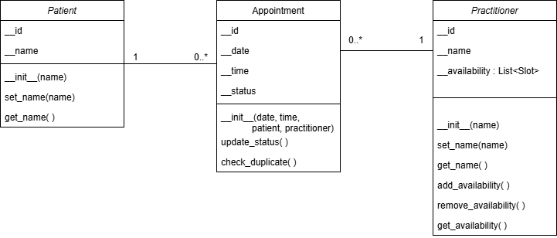

Design Rationale
Explain class selection, responsibility allocation and key relationships.
The main classes in the model are Patient, Practitioner and Appointment because these are the main things SmartCare needs to manage. The case focuses on patient records, practitioner availability, appointment status, cancellations and appointment history, so these classes cover the main requirements.
Each class is given the responsibility that makes the most sense for it. Patient handles patient information, Practitioner handles practitioner availability, and Appointment handles appointment details, status and cancellation.
Patient and Practitioner are both linked to Appointment. One patient can have many appointments, and one practitioner can also have many appointments, while each appointment is linked to one patient and one practitioner. Appointment does not inherit from Patient because an appointment is not a type of patient. Clinic was left out as a class because the current system is for one clinic and the case does not give it much separate state or behaviour.

AI Design Review Record
AI suggestion | Evidence | Decision | Reason | Model change
PatientManager | Case requires patient management, but does not require a separate manager class. | Rejected | Patient-related responsibilities can stay with Patient. | None
PractitionerManager | Case requires practitioner management and visibility of availability. | Rejected | Practitioner-related responsibilities can stay with Practitioner. | None
AppointmentManager | Case requires appointment management, including status and cancellation. | Rejected | Appointment-related responsibilities can stay with Appointment. | None
ClinicController | System is for one small clinic, and the case does not give Clinic separate control responsibilities. | Rejected | Would add unnecessary complexity. | None
NotificationManager | Case does not mention notifications or reminders. | Rejected | No confirmed requirement supporting a notification class. | None
ScheduleEngine | Case mentions practitioner availability and duplicate bookings, but does not describe complex scheduling rules. | Modified | A scheduling engine could be useful later if the system becomes more complex, but it is not necessary for the current version. | Not added to the current model, but could be considered in a later iteration.

